First Semester 2026 Admn
MCA CP 106 Database Technology Lab (Mysql & Mongodb)
Module 2
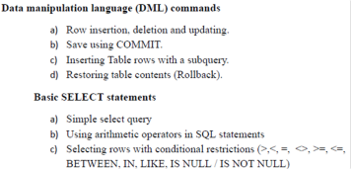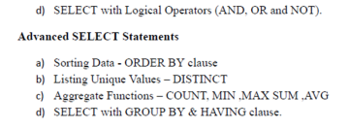

DML commands
4. TO INSERT, UPDATE AND DELETE
1. Create a table Deposit and insert the following values.
ACCNO | CNAME | BNAME | AMT | DDATE
1001 | Anil | VRC | 10000 | 1/3/2014
1002 | Sunil | AJNE | 50000 | 4/1/2015
1003 | Mehul | KarolBagh | 35000 | 17/11/2014
1005 | Madhuri | Chandini | 12000 | 17/12/2015
1006 | Pramod | MG road | 33000 | 27/3/2015
1007 | Sandeep | Andheri | 22000 | 31/3/2015
1008 | Naren | Andheri | 33000 | 12/2/2014

a) Insert a single record at a time.
b) Insert more than one record using a single insert command
c) Insert a single record into depositor table as values 1004, Meera,ANDHERI, 60000, 06/03/2015
2.Give 15% interest to all depositors
3.Give 25% interest to all depositors having branch VRC
4.Change the deposit of Anil to 20000 and change the name of branch as VRC_ANDHERI. 5. Delete the record with accno=1004 from the Deposit table.
6. Delete the details of customers who have their deposits in Chandini branch.
5. RETRIEVAL OF DATA USING SIMPLE SELECT QUERY
Note: Refer the table Deposit. Also create tables Branch, Customer, Borrow. Branch
BNAME | BCITY
VRC | Nagpur
JNE | Nagpur

KAROL BAGH | Delhi
CHANDINI | Delhi
MG ROAD | Bangalore
ANDHERI | Bombay

Customer
CNAME | LCITY
Anil | Calcutta
Sunil | Delhi
Mehul | Baroda
Madhuri | Nagpur
Pramod | Nagpur
Shivani | Bombay
Naren | Bombay

Borrow
LOAN_NO | CNAME | BNAME | AMT
201 | Anil | VRC | 1000
206 | Mehul | AJNE | 5000
311 | Sunil | ANDHERI | 3000
321 | Madhuri | NEHRU PLACE | 2000

1) Display the details from the above tables Deposit, Branch, Customer, Borrow.
(2) Display the names and deposited amount of all customers.
(3) Give names of all the branches.
(4) Give the names of all borrowers.
(5) Find the names of distinct branch cities.
6. RETRIEVAL OF DATA USING SELECT QUERY WITH WHERE CLAUSE
1. Display branch names located in city Delhi
2. Give the names of depositors who have deposit less than 30000
3. Give the deposit date of customer Mehul.
4. Give the names of borrower having loan number 206
5. Give the names of customers who opened account after date 1/1/15 6. Give the account number and deposited amount of customers having account opened between 1/1/2015 and 1/12/2015.
7. Give the names of all customers who have taken loans.
8. Display the names of depositors who reside in Delhi and having branch city Nagpur
9. Give the details of customer Sunil.
7. Perform Aggregate Functions
Use tables Deposit, borrow, branch, customer
1. Calculate total deposit amount of the customers
2. Calculate the total deposit of the customers who have taken an account after 27th January 2015.
3. Calculate the total deposit amount of the customers living in Nagpur city 4. Find the maximum deposit of customers living in Delhi city
5. Find the minimum loan amount taken from the ajne branch
6. Find the total no. of branch city
7. Find the total no. of customers.

8. Perform Sorting of data
1. Sort the table customer in the descending order of customer names.
2. Sort the table branch in the ascending order of branch city. 9.Perform the following queries using GROUP BY AND HAVING CLAUSE
1. Give the branch name and branch wise deposit
2. Give the living city wise name and corresponding deposit amount
3. Give the branch wise deposit of customers after a date 1-1-2015. 4. Give the branch wise deposit of customers living in Delhi
5. Give the name of the branch where the number of depositors is more than 1.
6. Give the customer name and minimum deposited amount in the ‘Andheri’ branch.
7. Give the name of the city having the same number of customers living as that of Nagpur.
8. list the branches having the sum of deposits >30000.
9. List the branches having the sum of deposit more than 4000 and located in city Delhi
10. Display the deposited amount along with the no.of depositors living in Nagpur

Module 3
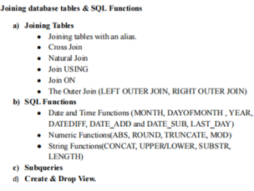10 FUNCTIONS
A. Numeric Functions
1. Abs(-5)
2. Cos (0)
3. Sin(0)
4. Ceiling(90.9)
5. Floor(90.9)
6. Truncate(1.83579,3)
7. Mod(31,3)
8. Power(2,3)
9. Exp(2)
10.Round(5)
11.Sqrt(25)
12.greatest(99,56)
13.least(99,56)
14.bin(12)
15.oct(8)
16.hex(13)
B. STRING FUNCTIONS
1.Display the customer names in deposit table in lower case
2. Display customer names in deposit table in uppercase
3. Display the customer name and length of each name.
4.Find the length of a string in bits.
5.Extract a specific no. of characters from the left and right of a particular string.
6. Concatenate two strings
7. Concatenate customer name and branch name from the table deposit 8. Concatenate two strings with comma as the separator.
9 . Find the ascii value of a character.
10. Compare two strings.
11.Reverse a string.
12. Extract 5 characters from the string “hello world” starting with ‘l’. 13. Find the location of the substring “come” in the string “welcome” 14.Find the position of a particular string in a set of strings. 15. translate()
16. Replace(), insert()
17. rpad() , lpad()
18. ltrim(),rtrim()
19. Trim()
C. Date Functions
1. curtime(), curdate()
2. year()
3. month(), monthname()
4.dayofyear(), dayofmonth(), dayofweek()
5. hour(), minute(), second()
6.to_days()
7. from_days()
8. date_add(), date_sub()
9. extract()
10. period_diff()
11. SUB-QUERIES
1.Insert into deposit a new record (107,Sandeep,Ajne,2000,12032011).Display the customers' names whose branch is same as that of the branch of Sndeep.
2.Give the number of customers who are depositors as well as borrowers. 3.Delete the record from loans who have a deposit.
12. VIEWS IN DBMS
1. Create a view for the table deposit with fields accno, cust name and branch name
2. Create a view that gives information about customer name, deposit amount and living city
3. Create a view to display the borrow details having loan no 206
4. Drop a view

